Supplemental Material
Table S1
Performance metrics and hyperparameter from all iterations of the regularized Cox Regression
Iteration | C-index (training) | C-index (testing) | CRPS (training) | CRPS (testing) | alpha | lambda.1se
1 | 0.723 | 0.723 | 0.104 | 0.100 | 0.4 | 0.129
2 | 0.727 | 0.692 | 0.102 | 0.105 | 0.9 | 0.061
3 | 0.744 | 0.726 | 0.091 | 0.120 | 0.6 | 0.058
4 | 0.726 | 0.712 | 0.104 | 0.105 | 0.4 | 0.162
5 | 0.719 | 0.699 | 0.106 | 0.105 | 0.5 | 0.156
6 | 0.726 | 0.702 | 0.104 | 0.106 | 0.5 | 0.159
7 | 0.738 | 0.746 | 0.094 | 0.107 | 0.3 | 0.116
8 | 0.749 | 0.707 | 0.093 | 0.113 | 0.2 | 0.167
9 | 0.741 | 0.687 | 0.097 | 0.113 | 0.6 | 0.072
10 | 0.714 | 0.704 | 0.103 | 0.110 | 0.1 | 0.846
11 | 0.723 | 0.722 | 0.100 | 0.112 | 0.2 | 0.288
12 | 0.764 | 0.718 | 0.059 | 0.183 | 0 | 4.210
13 | 0.743 | 0.712 | 0.060 | 0.174 | 0 | 22.958
14 | 0.730 | 0.700 | 0.103 | 0.105 | 0.3 | 0.220
15 | 0.722 | 0.704 | 0.105 | 0.102 | 0.4 | 0.151
16 | 0.731 | 0.704 | 0.100 | 0.110 | 0.1 | 0.650
17 | 0.716 | 0.721 | 0.105 | 0.105 | 0.9 | 0.085
18 | 0.708 | 0.726 | 0.105 | 0.109 | 0.3 | 0.270
19 | 0.719 | 0.723 | 0.103 | 0.108 | 0.2 | 0.382
20 | 0.726 | 0.719 | 0.099 | 0.113 | 0.1 | 0.649
Note. C-index = Harrell’s Concordance Index, CRPS = continuous rank probability score,
lambda.1se = largest λ such that the error is within one standard error of the minimum mean cross-validated error.

Table S2
Performance metrics and hyperparameter from all iterations of Random Survival Forest
Iteration | C-Index (training) | C-Index (testing) | CRPS (training) | CRPS (testing) | mtry | nodesize
1 | 0.837 | 0.735 | 0.140 | 0.242 | 7 | 55
2 | 0.831 | 0.716 | 0.184 | 0.173 | 6 | 55
3 | 0.947 | 0.743 | 0.127 | 0.177 | 7 | 9
4 | 0.969 | 0.700 | 0.205 | 0.281 | 22 | 3
5 | 0.983 | 0.693 | 0.136 | 0.172 | 10 | 1
6 | 0.976 | 0.717 | 0.139 | 0.441 | 10 | 2
7 | 0.960 | 0.760 | 0.155 | 0.187 | 5 | 6
8 | 0.978 | 0.699 | 0.192 | 0.267 | 8 | 2
9 | 0.958 | 0.731 | 0.123 | 0.193 | 41 | 6
10 | 0.955 | 0.706 | 0.135 | 0.327 | 7 | 7
11 | 0.861 | 0.707 | 0.124 | 0.153 | 8 | 40
12 | 0.945 | 0.722 | 0.131 | 0.172 | 27 | 10
13 | 0.817 | 0.726 | 0.133 | 0.189 | 6 | 65
14 | 0.827 | 0.709 | 0.129 | 0.160 | 7 | 60
15 | 0.958 | 0.723 | 0.133 | 0.227 | 27 | 6
16 | 0.831 | 0.751 | 0.140 | 0.213 | 6 | 60
17 | 0.973 | 0.690 | 0.142 | 0.271 | 22 | 2
18 | 0.830 | 0.783 | 0.125 | 0.219 | 15 | 65
19 | 0.977 | 0.740 | 0.150 | 0.219 | 10 | 2
20 | 0.954 | 0.704 | 0.153 | 0.198 | 41 | 7
Note. C-index = Harrell’s Concordance Index, CRPS = continuous rank probability score.

Figure S1
Averaged Variable Importance of the Random Survival Forest
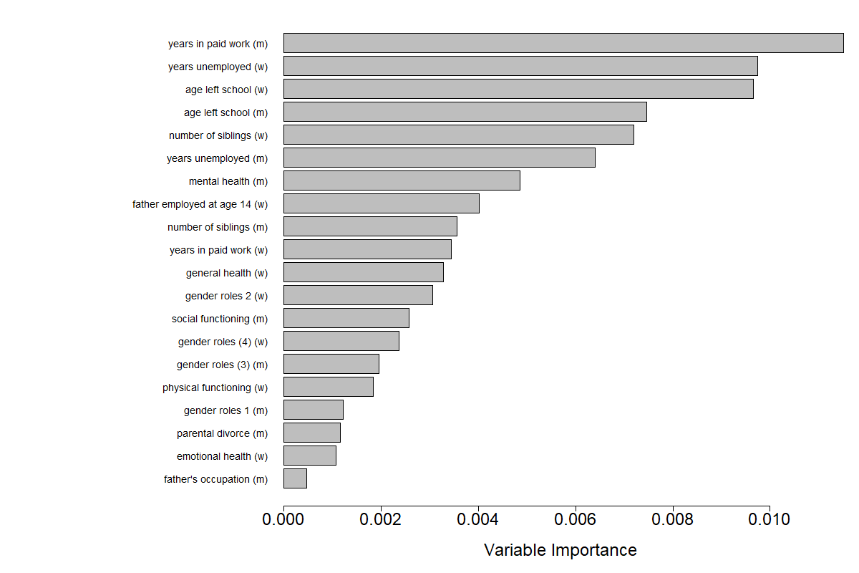
Note. The 20 most frequently selected predictors across 20 iterations are shown. Variable importance is calculated per default via anti-split assignment (Ishwaran & Kogalur, 2012). (m) and (w) denote variables referring to men and women. gender roles 1 = As long as the care is good, it is fine for children under 3 years of age to be placed in child care all day for 5 days a week , gender roles 2 = If both partners in a couple work, they should share equally in the housework and care of children , gender roles 3 = Whatever career a man may have, his most important role in life is still that of being a father, gender roles 4 = Whatever career a woman may have, her most important role in life is still that of being a mother. years unemployed = years unemployed and looking for work.

